INTERNSHIP REPORT – TASK II
Name: [Navya Thalathoti]
Internship: CodeAlpha
Course / Department: [Bioinformatics] B.TECH
Gmail:navyathalathoti@gmail.com

Title:
Multiple Sequence Alignment and Conserved Region Analysis of Protein Family Members using Clustal Omega and WebLogo3

Objective:
To perform multiple sequence alignment (MSA) on five protein sequences belonging to the same family using Clustal Omega and identify conserved amino acid residues using WebLogo3 visualization.

Introduction:
Proteins belonging to the same family often share similar structures and functions. Multiple Sequence Alignment (MSA) helps identify conserved regions which are essential for maintaining biological activity and structural stability.
WebLogo3 is a visualization tool that represents these conserved regions graphically, showing the frequency of each amino acid at specific positions in aligned sequences. This analysis helps in understanding evolutionary conservation and functional importance within protein families.

Materials and Tools Used:
Category | Details
Database | UniProt (for sequence retrieval)
Software Tools | Clustal Omega (MSA), WebLogo3 (Logo visualization)
Input Format | FASTA
Output Format | PNG (WebLogo image)
System Requirement | Any web browser with internet connection

Protein Family Selected:
Cytochrome P450 family CYP
S. No | Species | Protein Name | UniProt ID
1 | Homo sapiens (Human) | CYP1A1 | P04798
2 | Homo sapiens (Human) | CYP3A4 | P08684
3 | Drosophila melanogaster (Fruit fly) | CYP6G1 | Q9V674
4 | Caenorhabditis elegans (Nematode worm) | CYP35B1 (Dod-13) | O44650
5 | Homo sapiens (Human) | CYP51A1 | Q16850

Methodology (Step-by-Step):
Step 1: Sequence Retrieval from UniProt
- Accessed https://www.uniprot.org
- Searched for “Cytochrome c” in different species.
- Downloaded all five sequences in FASTA format.
(Figure 1: Protein sequence of Cytochrome retrieved from UniProt database.)
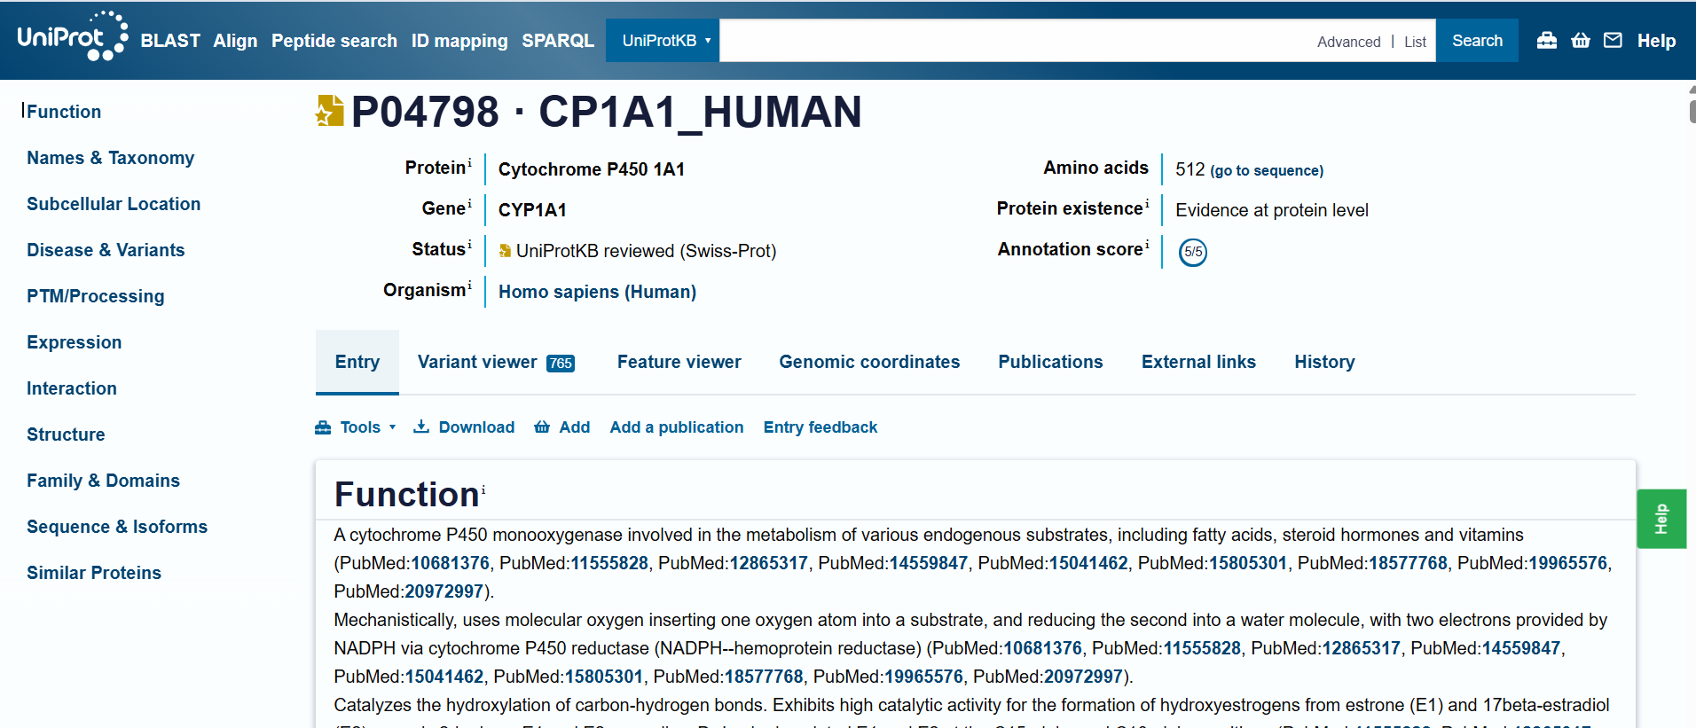
(JUST SAMPLE)

SEQUENCES:
>sp|P04798|CP1A1_HUMAN Cytochrome P450 1A1 OS=Homo sapiens OX=9606 GN=CYP1A1 PE=1 SV=1
MLFPISMSATEFLLASVIFCLVFWVIRASRPQVPKGLKNPPGPWGWPLIGHMLTLGKNPH
LALSRMSQQYGDVLQIRIGSTPVVVLSGLDTIRQALVRQGDDFKGRPDLYTFTLISNGQS
MSFSPDSGPVWAARRRLAQNGLKSFSIASDPASSTSCYLEEHVSKEAEVLISTLQELMAG
PGHFNPYRYVVVSVTNVICAICFGRRYDHNHQELLSLVNLNNNFGEVVGSGNPADFIPIL
RYLPNPSLNAFKDLNEKFYSFMQKMVKEHYKTFEKGHIRDITDSLIEHCQEKQLDENANV
QLSDEKIINIVLDLFGAGFDTVTTAISWSLMYLVMNPRVQRKIQEELDTVIGRSRRPRLS
DRSHLPYMEAFILETFRHSSFVPFTIPHSTTRDTSLKGFYIPKGRCVFVNQWQINHDQKL
WVNPSEFLPERFLTPDGAIDKVLSEKVIIFGMGKRKCIGETIARWEVFLFLAILLQRVEF
SVPLGVKVDMTPIYGLTMKHACCEHFQMQLRS
>sp|P08684|CP3A4_HUMAN Cytochrome P450 3A4 OS=Homo sapiens OX=9606 GN=CYP3A4 PE=1 SV=4
MALIPDLAMETWLLLAVSLVLLYLYGTHSHGLFKKLGIPGPTPLPFLGNILSYHKGFCMF
DMECHKKYGKVWGFYDGQQPVLAITDPDMIKTVLVKECYSVFTNRRPFGPVGFMKSAISI
AEDEEWKRLRSLLSPTFTSGKLKEMVPIIAQYGDVLVRNLRREAETGKPVTLKDVFGAYS
MDVITSTSFGVNIDSLNNPQDPFVENTKKLLRFDFLDPFFLSITVFPFLIPILEVLNICV
FPREVTNFLRKSVKRMKESRLEDTQKHRVDFLQLMIDSQNSKETESHKALSDLELVAQSI
IFIFAGYETTSSVLSFIMYELATHPDVQQKLQEEIDAVLPNKAPPTYDTVLQMEYLDMVV
NETLRLFPIAMRLERVCKKDVEINGMFIPKGVVVMIPSYALHRDPKYWTEPEKFLPERFS
KKNKDNIDPYIYTPFGSGPRNCIGMRFALMNMKLALIRVLQNFSFKPCKETQIPLKLSLG
GLLQPEKPVVLKVESRDGTVSGA
>sp|Q9V674|CP6G1_DROME Cytochrome P450 6g1 OS=Drosophila melanogaster OX=7227 GN=Cyp6g1 PE=2 SV=1
MVLTEVLFVVVAALVALYTWFQRNHSYWQRKGIPYIPPTPIIGNTKVVFKMENSFGMHLS
EIYNDPRLKDEAVVGIYSMNKPGLIIRDIELIKSILIKDFNRFHNRYARCDPHGDPLGYN
NLFFVRDAHWKGIRTKLTPVFTSGKVKQMYTLMQEIGKDLELALQRRGEKNSGSFITEIK
EICAQFSTDSIATIAFGIRANSLENPNAEFRNYGRKMFTFTVARAKDFFVAFFLPKLVSL
MRIQFFTADFSHFMRSTIGHVMEERERSGLLRNDLIDVLVSLRKEAAAEPSKPHYAKNQD
FLVAQAGVFFTAGFETSSSTMSFALYEMAKHPEMQKRLRDEINEALVEGGGSLSYEKIQS
LEYLAMVVDEVLRMYPVLPFLDREYESVEGQPDLSLKPFYDYTLENGTPVFIPIYALHHD
PKYWTNPSQFDPERFSPANRKNIVAMAYQPFGSGPHNCIGSRIGLLQSKLGLVSLLKNHS
VRNCEATMKDMKFDPKGFVLQADGGIHLEIVNDRLYDQSAPSLQ
>tr|O44650|O44650_CAEEL CYtochrome P450 family OS=Caenorhabditis elegans OX=6239 GN=cyp-35b1 PE=1 SV=2
MIFVLLLTTFLAVLIIRQYQKARKLPPGPVSLPLIGNIHQLVYHIWNEKGVVPAFDLFRK
KYGDVFTIWLGPIPHVSICNYETSQEVFVKNGNKYKDRFLPPVYLHVSNNLGLFTANGPV
CAEMRKFTLLAFRNMGVGRDLMEQRILDELNTRCAEIDADAVNGKTIVHTTEFFDLTVGS
VINSLLVGKRFEAEDKDDFLEIKRLMAEAADLFTMFDLVVPVWFLKSFFPSRFERVVAIF
EKALNYLSREALARYEKLKTGEYSVNAEDPQDFVEAYLAKMEQERLRDSDTPYTMECLKF
VIGDLWLAGQDTTSTTLVAGFNHLVKNPEIVRKCREEILRITENGSRPLQLKDRAESHYL
NATIAEIQRHASILNVNFWRLVHEPTTVQGHPVDSGSVICAQLGALHVNDDLFKNPDKFY
PERFIENEQLLSQIIPFGIGKRSCVGENIAKSELYLMIGNLILRYDIKPHGSEPSTEDKL
PYSAGKTPDKSVKLEFVKL
>sp|Q16850|CP51A_HUMAN Lanosterol 14-alpha demethylase OS=Homo sapiens OX=9606 GN=CYP51A1 PE=1 SV=4
MAAAAGMLLLGLLQAGGSVLGQAMEKVTGGNLLSMLLIACAFTLSLVYLIRLAAGHLVQL
PAGVKSPPYIFSPIPFLGHAIAFGKSPIEFLENAYEKYGPVFSFTMVGKTFTYLLGSDAA
ALLFNSKNEDLNAEDVYSRLTTPVFGKGVAYDVPNPVFLEQKKMLKSGLNIAHFKQHVSI
IEKETKEYFESWGESGEKNVFEALSELIILTASHCLHGKEIRSQLNEKVAQLYADLDGGF
SHAAWLLPGWLPLPSFRRRDRAHREIKDIFYKAIQKRRQSQEKIDDILQTLLDATYKDGR
PLTDDEVAGMLIGLLLAGQHTSSTTSAWMGFFLARDKTLQKKCYLEQKTVCGENLPPLTY
DQLKDLNLLDRCIKETLRLRPPIMIMMRMARTPQTVAGYTIPPGHQVCVSPTVNQRLKDS
WVERLDFNPDRYLQDNPASGEKFAYVPFGAGRHRCIGENFAYVQIKTIWSTMLRLYEFDL
IDGYFPTVNYTTMIHTPENPVIRYKRRSK

Step 2: Multiple Sequence Alignment using Clustal Omega
- Opened Clustal Omega tool: https://www.ebi.ac.uk/Tools/msa/clustalo/
- Pasted the five FASTA sequences into the input box.
- Selected output format: Clustal with numbers.
- Submitted the job and waited for results.
- Downloaded the alignment result and saved it for visualization.

(Figure 2: Submission of Cytochrome c sequences to Clustal Omega for multiple sequence alignment.)
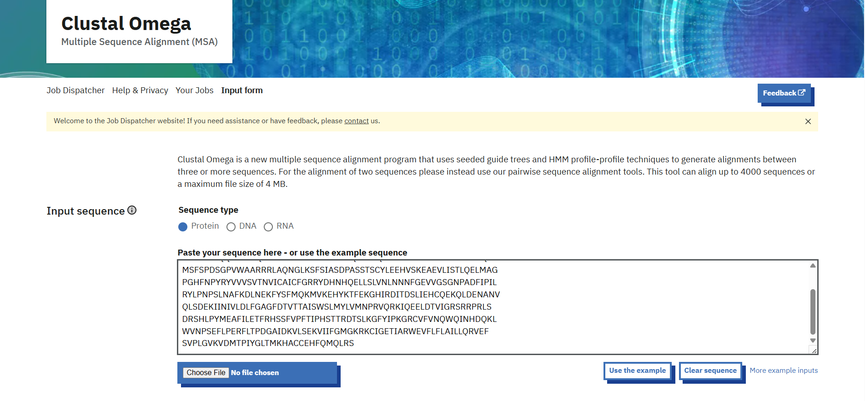
(Figure 3: Multiple sequence alignment output showing conserved residues across Cytochrome c family members.)

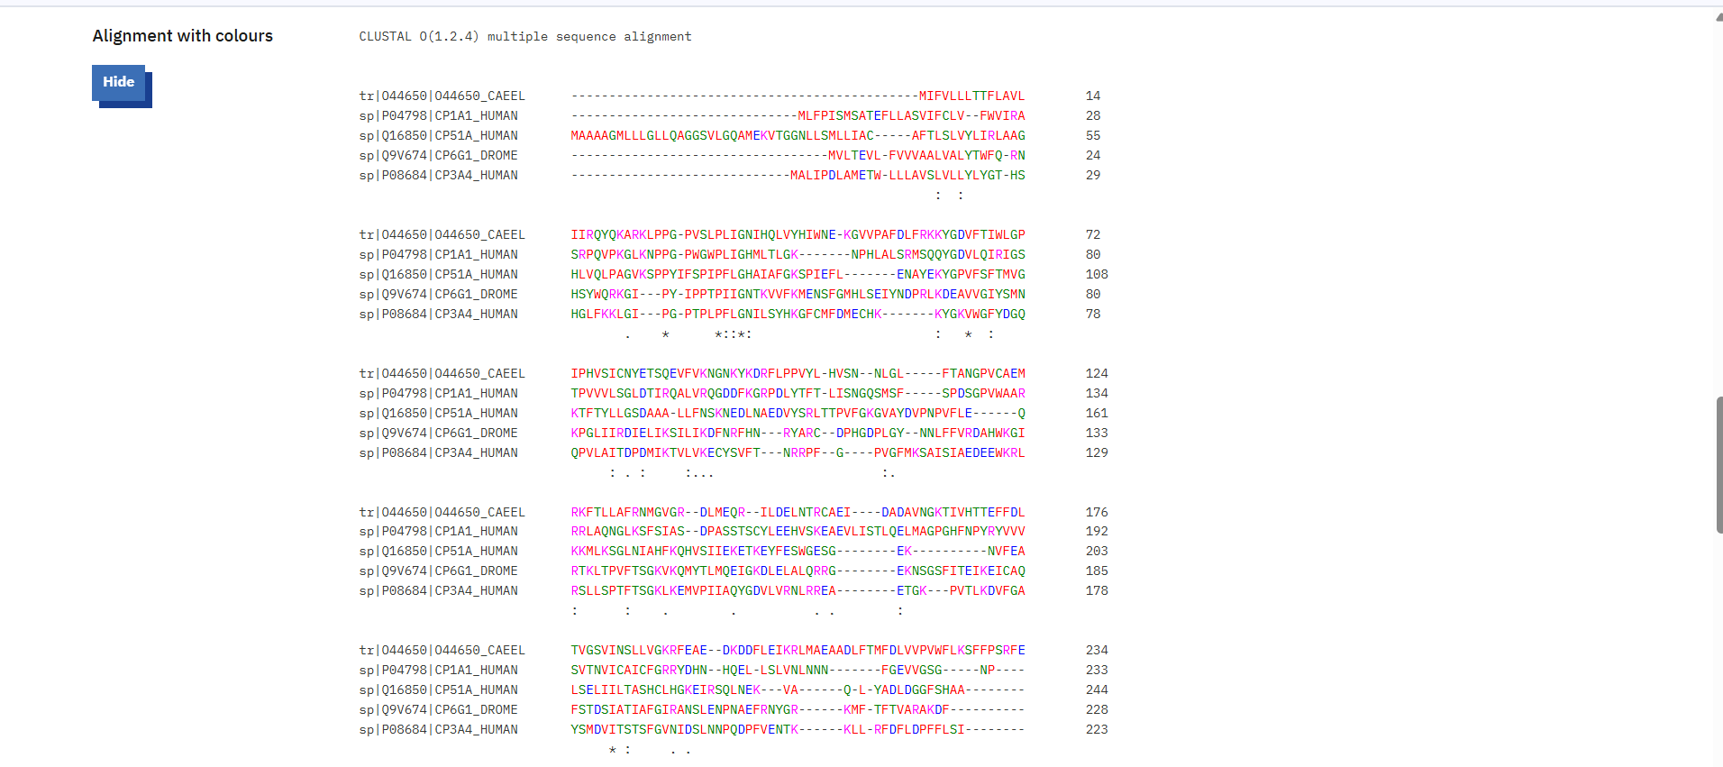
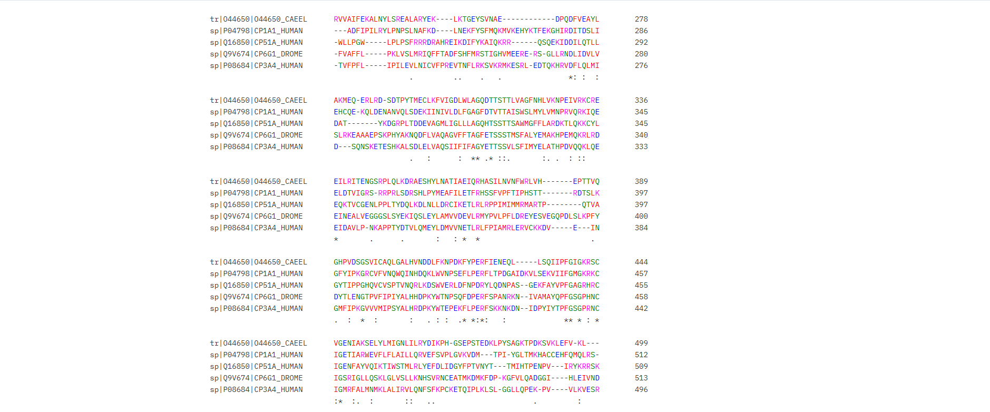

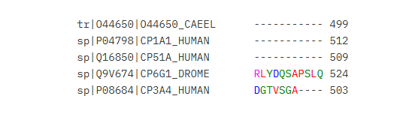

Step 3: Conserved Region Visualization using WebLogo3
- Opened WebLogo3: https://weblogo.berkeley.edu/logo.cgi
- Uploaded the aligned FASTA file from Clustal Omega.
- Selected:
  - Sequence Type: Protein
  - Output Format: PNG
- Clicked on “Create Logo” to generate the visual representation of conserved residues.
- Downloaded the WebLogo image.

(Figure 4: Aligned sequences uploaded to WebLogo3 for logo generation.)

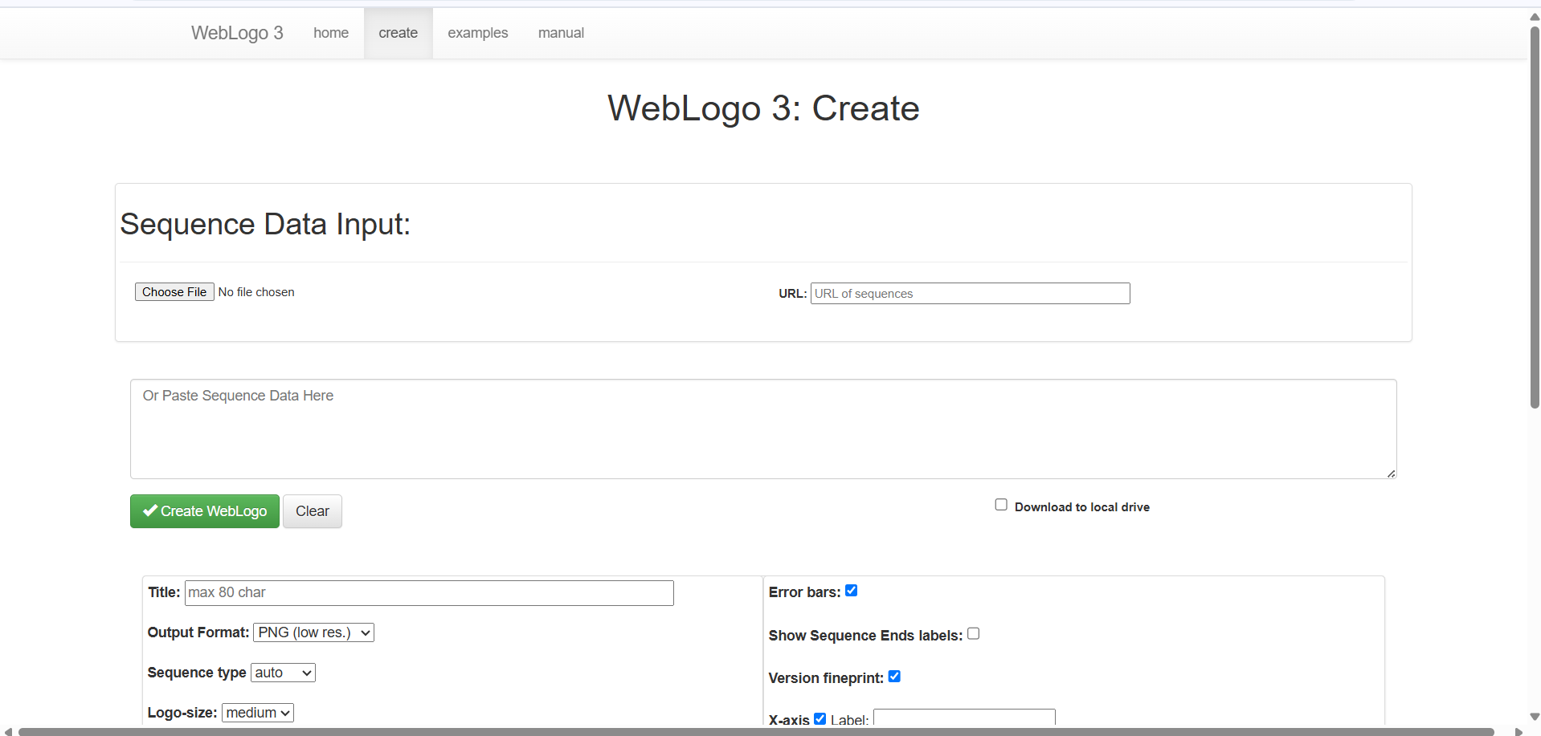
(Figure 5: WebLogo output displaying conserved amino acid residues across Cytochrome c family.)

Results and Observations:

Results and Observations:
- The MSA revealed strong conservation in specific regions of the Cytochrome c sequence.
- The WebLogo visualization clearly showed Cysteine (C), Histidine (H), and Glycine (G) residues as highly conserved among all species.
- Tall stacks in the WebLogo indicate highly conserved positions, while shorter stacks indicate variable amino acids.

Interpretation:
The conserved amino acid residues correspond to essential functional sites involved in heme binding and electron transport.
Variations at certain positions reflect evolutionary adaptations while maintaining the core structure and function of Cytochrome c proteins across species.

Conclusion:
This analysis confirms that Cytochrome c proteins from humans, animals, and yeast share strong evolutionary conservation.
The MSA and WebLogo3 visualization effectively highlight the functional importance of conserved residues critical to protein stability and biological activity.

